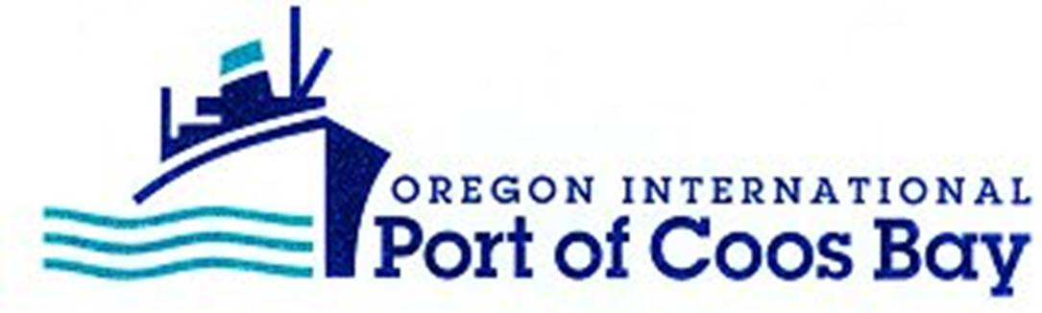

M E M O R A N D U M

TO: Interested Parties

FROM: Eric Farm, President

DATE: December 6, 2023

SUBJECT: Port of Coos Bay Commission Executive Session Notice

The Board of Commissioners of the Oregon International Port of Coos Bay will meet in Executive Session on Wednesday, December 6, 2023, at 10:00 a.m.

No decisions will be made in Executive Session. This session is closed to the general public.

The purpose of this Executive Session, as authorized under ORS 192.660(2), is to:

i) review and evaluate the job performance of a chief executive officer, other officers, employees and staff, if the person whose performance is being reviewed and evaluated does not request an open hearing.

EF/lf

